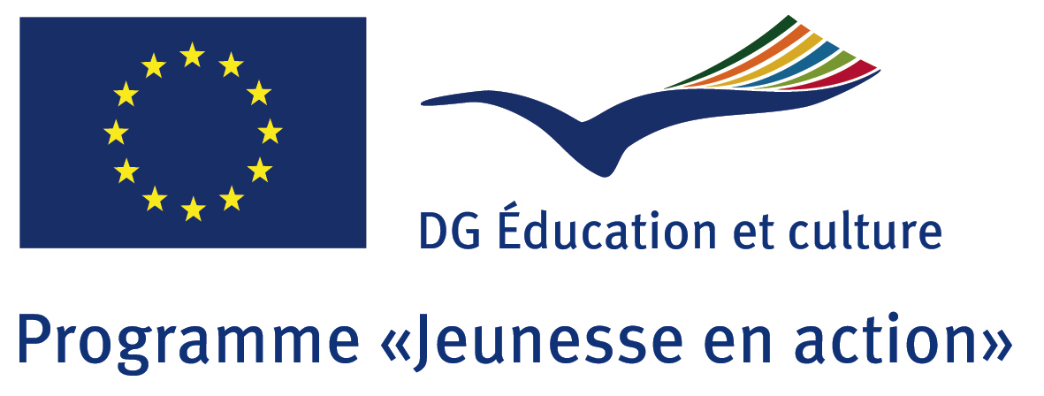

Agence Française du Programme européen
Jeunesse en Action

PARTNER REQUEST FROM FRANCE
FOR A YOUTH EXCHANGE (Action 1.1)

Merci de remplir cette fiche en anglais ou dans la
langue du pays que vous souhaitez avoir comme partenaire

Name of organisation / Nom de l’organisation : La Garrigue au coeur
Address / Adresse : 6, Impasse des lavoirs – 34820 TEYRAN
Country / Pays : France
Name of contact person / Nom de la personne de contact : Sylvie CAMALON
Languages spoken / Langues parlées : french, english, spanish, some russian
Telephone / Téléphone :0033467870623 (Mobile : 0664254320)
E-mail : scamalon@laposte.net

Describe your organisation / Présentation de l’organisation :
Association that aims to preserve, defend the local environment of a village (Teyran, South of France, 5000 inhabitants, 10 kms far from Montpellier city and seaside), and all appropriate actions and natural heritage (fauna and flora), including cultural activities (conferences, travels).

Describe your target group (age, size, social situation, status, gender, etc.)
Profil des participants (taille, tranche d’âge, situation sociale et/ou géographique, filles/garçons, etc.)
Target is to create 2 groups of young people who could be mutually received in rural and urban surroundings.
Complete group would be made of one group of max 30 young people (14-18 years), one half from each country (half boys, half girls), some can be with fewer opportunities.

What kind of project do you want to do (theme, activities ...)?
Quel type de projet souhaitez-vous mettre en place (thème, activités,…) ?
Environmental discovering:
Our project would be based on a bilateral youth exchange which will allow young persons to mutually discover surrounding of both regions, richness of each environment but also what could be environmental issues. Treated topics : discovering of both type of surroundings (animal species, plants, climate), determine differences between countries (environmental conditions, regulations), find out a complete analysis of both conditions, exchange experience of what could be improved and how to preserve this .

First stay could take place in Teyran and nearby areas. Studied environment would be mainly a fragile natural environment : the garrigue, and the lagoon
Met areas : timberland, fields, seaside
Met people : inhabitants, forest keeper, farmers, scientists (botanist, geologist, ornithologist)

Cultural exchange :
Young persons will live with host family (and vice versa during second stay).
They will study into small bilateral groups by also exchange all together with whole group.

Partner country(ies) of preference (if any) / Pays que vous souhaiteriez avoir comme partenaire :
Spain, Ireland, United Kingdom

Do you already have other partners ? / Avez-vous déjà d’autres partenaires ? : NO

What do you prefer ? / Que préférez-vous ? :
X Bilateral exchange / Un échange bilatéral  Trilateral  Multilateral

X Hosting / Accueillir X Sending / Envoyer
 Don’t mind / Sans préférence

When do you want to do the project ? / Quand souhaitez-vous réaliser le projet ? July - August 2013

Working language(s) of the project / Langue(s) utilisée(s) pour le projet : Spanish, french, english,

Do you want to add something? / Quelque chose à ajouter? :
This project will be also devoted to enjoy being together, discover country and people.
These times together will encourage bilateral exchange, participation of all, and mutual respect.



